18KU30A 2000 5650KW 50HZ X 2UNITS

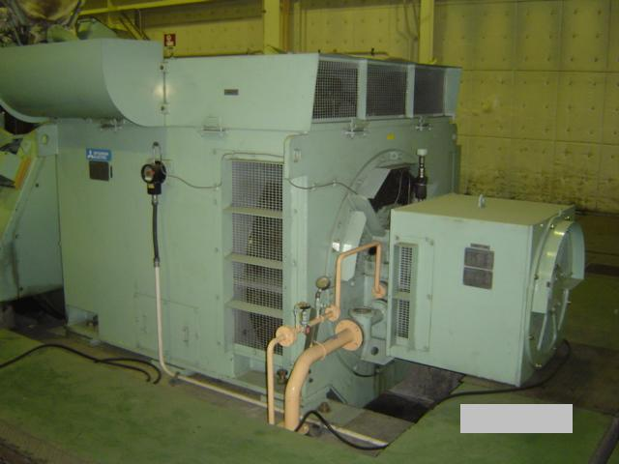
Price：
MAKER | MITSUBISHI
TYPE | 18KU30A
MFG YEAR | 2001
SPEC
OUTPUT | 5,650KW
REVOLUTION | 750 rpm
CYL. NO. , | 18
BORE
STROKE | 380mm
FUEL | DIESEL
QTY | 2 UNIT
RUNNING HR | No.1 : 51,129HR  No.2 : 48,000HR
LAST OVERHAUL | 2007,OCT,11
STOP ENGINE | 2008,JAN

Engine Manufacturer
Years
Model
Year of Manufacture
Total Hours No. 1
Total Hours No. 2
Rated Output in KW
RPM
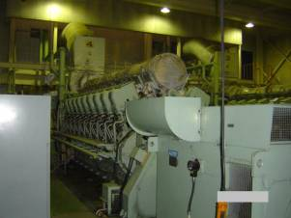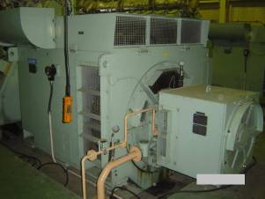
Generator Manufacturer
Model
Year of Manufacture
Total Hours No. 1
Total Hours No. 2
Output in Kw
Output Voltage
Frequency
Power Factor
RPM
Weight: & Dimension
L = mm
H = mm
R = mm
Net weight kgs
NO. | Quantity |  | Weight Description
1 |  |  | Skid mounted Wartsila 18V26 @ 1000 rpm & ABB Alternator, 6150KVA,50 HZ, 6,300 Volts
2 |  |  | Walkways for engine skids
3 |  |  | Exhaust System to Waste boilers
4 |  |  | Waste heat boilers for steam supply for HFO heating
5 |  |  | Silencers for exhaust
6 |  |  | Plate heat exchangers for engine cooling
7 |  |  | HFO Centrafuges for treatment of HFO fuel
8 |  |  | Fuel transfer Pumps
9 |  |  | HFO heating tank for Viscosity Control centre
10 |  |  | HFO Viscosity control Skid
11 |  |  | All associated Pipe work
12 |  |  | Air intake pipe work System to Ar cleaners and Air Cleaners
13 |  |  | Water treatment for Boilers
14 |  |  | Starter System Air Reciever
15 |  |  | Air Compressor for Air start System
16 |  |  | Engine top up Oil Storage tank and piping and valves and pump
17 |  |  | Gen Sync comtrol board
18 |  |  | Auxiliary Switch control boards
19 |  |  | HFO Day heated, insulated tanks & ass. pipe work, Pumps & valves
20 |  |  | Complete Fuel Delivery pump Station and all pumping and valve equipment
21 |  |  | Cooling Towers and all Pumping and piping and valves
22 |  |  | Overhead crane for maintaince
23 |  |  | Manuals, Installation Manual & operating manuals& spare parts manuals
24 |  |  | Aprox US 150,000 worth of NEW spare operational Spares
COMPLETE OPERATIONAL POWER PLANT FROM FUEL DELIVERY TO SYNC BOARD
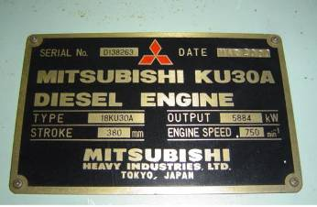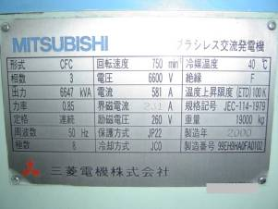
A.0 GENERAL MAIN DATA
A.0.0 General:
The power plant was designed, engineered and delivered by Stork Wartsila diesel.
A.0.1 Type of power plant:
The diesel generating sets were designed for heavy fuel oil operation.
A.0.2 Main data, conditions:
The total electrical output is generated by two (2) diesel generating sets of type 18V26,
at 1000RPM, with the following electrical characteristics.
Station nominal output (ISO)
Generator nominal output
Voltage
Frequency
Auxiliary voltage
Station actual output at site
A.1 DIESEL GENERATING SET
A.1.1 Diesel engine：
Technical data：
Engine type:
Number of cylinders |  |  |  |  |  |  |  |  |  |  |  |  |  |  |  | in Vee
Bore |  |  |  |  |  |  |  |  |  |  |  |  |  |  |  | mm
Stroke |  |  |  |  |  |  |  |  |  |  |  |  |  |  |  | mm
Maximum continuous rating |  |  |  |  |  |  |  |  |  |  |  |  |  |  |  | kWm
Speed |  |  |  |  |  |  |  |  |  |  |  |  |  |  |  | RPM
Direction of rotation facing flywheel side |  |  |  |  |  |  |  |  |  |  |  |  |  |  |  | Clock wise
Fuel consumption. Based on fuels having a calorific value of 42,700 kJ/kG at 100% load 186g/kWh
A.1.2 Generator: (Design and construction) Two (2) three-phase, brushless self-regulating
rotating field synchronous generator with AC-exciter and rectifier dics in line
incorporated electronic voltage regulator and equipped with damper wading, suitable formutual parallel operation.
 |  |  |  |  |  |  |  |  | Technical data:
Rating (at site conditions) |  |  |  |  |  |  |  |  | kVA
Output |  |  |  |  |  |  |  |  | kW
Efficiency |  |  |  |  |  |  |  |  | %
Power factor
Voltage: frequency |  |  |  |  |  |  |  |  | Volts/50 Hz
Speed |  |  |  |  |  |  |  |  | RPM
A.2 AUXILIARY SYSTEMS
A.2.1 Fuel system
A.2.1.0 Type of fuel: Heavy fuel oil 380 cst (50°C)
A.2.1.1 Heavy fuel oil system:
The heavy fuel oil is transferred from a storage tank by the transfer pumps to the settling tank. From the settling tank the fuel oil is pumped to the separator unit where it is purified. After purification the fuel is transferred to day tank and then supply to engine for operation.
SYSTEM COMPOSITION.
A.2.1.1.0 heavy fuel oil unloading module(U691), including
Electrical motor driven pump |  |  |  |  |  |  |  |  |  |  |  |  |  |  | set
Flow rate: |  |  |  |  |  |  |  |  |  |  |  |  |  |  | M³/h
Electrical motor, each |  |  |  |  |  |  |  |  |  |  |  |  |  |  | kW
Pressure head |  |  |  |  |  |  |  |  |  |  |  |  |  |  | bar
Control panel |  |  |  |  |  |  |  |  |  |  |  |  |  |  | set
Common base frame of steel |  |  |  |  |  |  |  |  |  |  |  |  |  |  | set
Valve and connection pipe |  |  |  |  |  |  |  |  |  |  |  |  |  |  | set
A.2.1.1.1 H.F.O. transfer module (U692), including
Electrical motor driven pump |  |  |  |  |  |  |  |  |  |  |  |  |  | set
Flow rate |  |  |  |  |  |  |  |  |  |  |  |  |  | M³/h
Electrical motor, each |  |  |  |  |  |  |  |  |  |  |  |  |  | kW
Pressure head |  |  |  |  |  |  |  |  |  |  |  |  |  | bar
Control Panel |  |  |  |  |  |  |  |  |  |  |  |  |  | set
Common base frame of steel |  |  |  |  |  |  |  |  |  |  |  |  |  | set
Valve and connection pipe |  |  |  |  |  |  |  |  |  |  |  |  |  | set
A.2.1.1.2 H.F.O. buffer tank (V 673), including:
Capacity |  |  |  |  |  |  |  |  |  |  |  | M³
High and low level alarm |  |  |  |  |  |  |  |  |  |  |  | set
Locally mounted level indicator |  |  |  |  |  |  |  |  |  |  |  | set
Steam heater 7 bars |  |  |  |  |  |  |  |  |  |  |  | set
Type of tank |  |  |  |  |  |  |  |  |  |  |  | Horizontal
A.2.1.1.3 H.F.O. service tank (V 671), including
Capacity |  |  |  |  |  |  |  |  |  |  |  | M³
High and low level alarm |  |  |  |  |  |  |  |  |  |  |  | set
Locally mounted level indicator |  |  |  |  |  |  |  |  |  |  |  | set
Steam heater 7 bars |  |  |  |  |  |  |  |  |  |  |  | set
Type of tank |  |  |  |  |  |  |  |  |  |  |  | Horizontal
A.2.1.2 Light fuel oil system:
The light fuel oil is unloaded from the truck to storage tank and suply to the engine for cold starting condition.
SYSTEM COMPOSITION.
A.2.1.2.0 light fuel oil unloading module(U631), including
Electrical motor driven pump |  |  |  |  |  |  |  |  |  |  |  |  |  | set
Flow rate |  |  |  |  |  |  |  |  |  |  |  |  |  | M³/h
Electrical motor, each |  |  |  |  |  |  |  |  |  |  |  |  |  | kW
Pressure head |  |  |  |  |  |  |  |  |  |  |  |  |  | bar
Control panel |  |  |  |  |  |  |  |  |  |  |  |  |  | set
Common base frame of steel |  |  |  |  |  |  |  |  |  |  |  |  |  | set
Valve and connection pipe |  |  |  |  |  |  |  |  |  |  |  |  |  | set
A.2.1.2.1 L.F.O. transfer module (U632), including
Electrical motor driven pump |  |  |  |  |  |  |  |  |  |  |  |  |  | set
Flow rate |  |  |  |  |  |  |  |  |  |  |  |  |  | M³/h
Electrical motor, each |  |  |  |  |  |  |  |  |  |  |  |  |  | kW
Pressure head |  |  |  |  |  |  |  |  |  |  |  |  |  | bar
Control panel |  |  |  |  |  |  |  |  |  |  |  |  |  | set
Common base frame of steel |  |  |  |  |  |  |  |  |  |  |  |  |  | set
Valve and connection pipe |  |  |  |  |  |  |  |  |  |  |  |  |  | set
A.2.2 LUBRICATING OIL SYSTEM
SYSTEM COMPOSITION.
A.2.2.0 Lubricating oil storage tank (V731), including：
Capacity |  |  |  |  |  |  |  |  |  |  | M³
High and low level alarm |  |  |  |  |  |  |  |  |  |  | set
Locally mounted level indicator |  |  |  |  |  |  |  |  |  |  | set
Steam heater 7 bars |  |  |  |  |  |  |  |  |  |  | set
Type of tank |  |  |  |  |  |  |  |  |  |  | Horizontal
A.2.2.1 Dirty lubricating oil storage tank (V734), including:
Capacity |  |  |  |  |  |  |  |  |  |  | M³
High and low level alarm |  |  |  |  |  |  |  |  |  |  | set
Locally mounted level indicator |  |  |  |  |  |  |  |  |  |  | set
Steam heater 7 bars |  |  |  |  |  |  |  |  |  |  | set
Type of tank |  |  |  |  |  |  |  |  |  |  | Horizontal
A.2.2.2 Combined HFO and lub-oil separator and booster module (U690):
A.2.2.2.0 HFO separator system：
․Automatic fuel oil separator suitable for cleaning heavy fuel oil (max s.g: 0.991).
Separator equipped with a built-on supply pump and built-in centripetal discharge
pump. Change over valve system, futher complete with electric motor.
․One steam heater, complete with safety valve and temperature regulator.
․Capacity 4,000 lits/hr at 380 cSt.
A.2.2.2.1 Lubricating oil separator system:
․Automatic lubricating oil separator suitable for cleaning lubricating oil (max s.g:
0.991). Separator equipped with a built-on supply pump and built-in centripetal
discharge pump. Change over valve system, futher complete with electric motor.
․One steam heater, complete with safety valve and temperature regulator.
․Capacity 4,800 lits/hr.
A.2.2.2.2 Heavy fuel oil booster module:
Automatic filter.
․Bypass filter (stand by).
․Mixing tank.
․Two circulation pumps.
․Two steam heaters.
․Viscosity control unit.
․Control panel complete with main switch and all control functions. Including relays, switches and lamps
A.2.3 COOLING SYSTEM:
SYSTEM COMPOSITION
A.2.3.0 Cooling tower system, including：
Cooling tower with centrifugal fans |  |  |  |  |  |  |  |  |  |  |  |  |  |  | set
Capacity |  |  |  |  |  |  |  |  |  |  |  |  |  |  | Cal
Wet bulb temperature |  |  |  |  |  |  |  |  |  |  |  |  |  |  | °C
Water outlet temperature |  |  |  |  |  |  |  |  |  |  |  |  |  |  | °C
Max water inlet temperature |  |  |  |  |  |  |  |  |  |  |  |  | °C
Electrical power, each |  |  |  |  |  |  |  |  |  |  |  |  | KW
Water pump unit with electrical motor Driven |  |  |  |  |  |  |  |  |  |  |  |  |  |  |  |  | set
Flow rate |  |  |  |  | M³/h
Electrical motor |  |  |  |  | KW
Control cabinet |  |  |  |  | set
A.2.3.1 Pre-heating module:
The pre-heating unit is used for the heating of H.T cooling water when starting the
engine in cold condition. Complete with electric driven pump.
A.2.3.2 HT cooling water heat exchanger: HT cooling water heat exchanger for
recooling of the high temperature water.
A.2.3.3 LT cooling water heat exchanger: LT cooling water heat exchanger for recooling
of the low temperature water.
A.2.3.4 Heat exchangers: the heat exchanger is used to transfer the heat available
from the engine high temperature system to the hot water system.
Air compressor electric driven 11 kW.
Capacity 34M3/h
Working pressure 30 bars.
Compressed air vessel. Capacity 1,500 lits working pressure 30bar complete with.
․inlet outlet valves.
․Safety valve.
․Pressure gauge.
․Drain valve.
A.2.5 Charge air system:
A.2.5.0 Charge air filter: Air intake filter of the oil bath type. Intended to prevent the entering of sand, dust etc. into the engine air intake.
A.2.5.1 Charge air silencer: air intake silencer, noise reduction 25 dB (A)
A.2.6 Exhaust gas system:
A.2.6.0 Exhaust gas silencer: the exhaust gas silencer without spark arrestor, noise reduction 25 dB(A). Complete with counter flange
A.2.6.1 Exhaust gas ducting bellows: Corrosion resistant bellows for fitting between the ducting and exhaust gas silencer.
A.2.6.2 Exhaust gas boiler: The exhaust gas boiler can produce the maximum amount of steam possible
․ Saturated steam production 3,600 kg/hr at 10 bar
․Steam generation at 170 0C
․The exhaust gas boiler system include the following:
․Exhaust gas boiler for mounting in the exhaust gas ducting.
․Evaporator coils with flanges.
․Soot blowing equipment.
․Standard assortment of valves, safety valves.
․Steam drum module including:
○ Blow down drains
○ Accumulator
○ Circulating pump
○ Safety valve and control valves
○ Control board.
Feed water module, including:
․Feed water pump
․Feed water tank
․Chemical treatment dosing unit
․Local control board
A.2.7 Electric system:
A.2.7.0 Main switchgear:
- 1 common part:
+ Three-phase busbar system
• Operating voltage  • Rated current  • Rated voltage  • Rated short time current |  |  |  |  |  |  |  |  | KV  AMPS  KV  KV/1SEC.
+2 Generator Cubicles:
1 triple-pole circuit breaker: vacuum draw out type
• Operating volt  • Rated current |  |  |  | KV  AMPS
1 station transformer cubicle (only high voltage):
•One triple-pole loadbreaker switch
• Operating voltage  • Three high volt fuses |  |  |  |  |  |  | KV  AMPS
Outgoing feeder cubicle:
One triple-pole circuit breaker: vacuum draw out type
Operating voltage  Rated current |  |  |  |  |  | KV  AMPS
A.2.7.1 Neutral earthing board:
-1 neutral earthing boards, each consisting of:
+Isolating switch, single pole, load break type, with mechanical interlock.
+ One neutral earthing resistor, non-corrosive

