SUPER LINES INTERNATILAL CORP.
TEL:86-769-83369606 E-MAIL: slchina@vip.163.com FAX:86-769-83369255
86-769-83369660 superlines@seed.net.tw
topslines@ssed.net.tw
TO: DATE: 2009/03/01
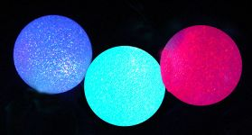 | ITEM NO: L-5866A LED STRING – 6“ BALLS  PRICE : FOB GUANGZHOU US$9.50/SET for UL  9.60/SET for EU  9.80/SET for BS  DESCRIPTION: 6” ball x 3 pcs for 3.3M length by LED  Color-changing  Power by Adaptor  PACKING: 1 set/color window box/ 32.5 x 32.5 x 15.5cm,  12 sets/ctn/ 7.61 cuft / 65.5 x 48 x 67.5cm/  13.0 kgs/ 16.0 kgs
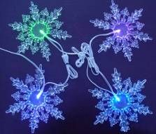 | ITEM NO: L-5866B LED STRING - SNOWFLAKES  PRICE : FOB GUANGZHOU US$9.80/SET for UL  US$9.90/SET for EU  US$10.10/SET for BS  DESCRIPTION: 6” x 8 pcs for 5.5M length by LED  Color-changing  Power by Adaptor  PACKING: 1 set/color window box/15.75x15.75 x12.75cm  12 sets/ctn/ 1.27 cuft/ 33 x 33 x 33cm/  17.8 kgs/ 19.6kgs
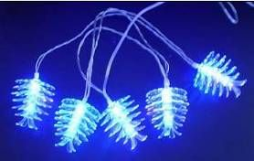 | ITEM NO: L-5866C LED STRING - PINECONES  PRICE : FOB GUANGZHOU US$7.90/SET for UL  US$8.00/SET for EU  US$8.20/SET for BS  DESCRIPTION: 2-1/4” x 10 pcs for 6M length by LED color-changing  Power by Adaptor  PACKING: 1 set/color window box/ 22.5 x 6 x 14.7cm,  12 sets/ctn/ 1.05 cuft/ 38 x 24.5 x 32cm/  8.0 kgs/ 9.80 kgs
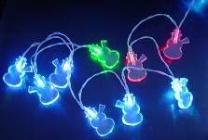 | ITEM NO: L-5866D LED STRING - SNOWMEN  PRICE : FOB GUANGZHOU US$8.25/SET for UL  US$8.35/SET for EU  US$8.55/SET for BS  DESCRIPTION: 1-1/2” x 10 pcs for 6M length by LED  Color-changing  Power by Adaptor  PACKING: 1 set/color window box/22.5 x 6 x 14.7cm,  12 sets/ctn/ 1.05 cuft/ 38 x 24.5 x 32cm/  8.0kgs/ 9.80kgs
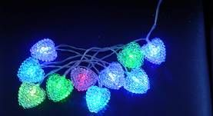 | ITEM NO: L-5866E LED STRING – SEA URCHINS  PRICE : FOB GUANGZHOU US$8.40/SET for UL  US$8.50/SET for EU  US$8.70/SET for BS  DESCRIPTION: 1-1/2” x 10 pcs for 6M length by LED  Color-changing  Power by Adaptor  PACKING: 1 set/color window box/ 22.5 x 6 x 14.7cm,  12 sets/ctn/ 1.05 cuft/ 38 x 24.5 x 32cm/  8.4kgs/ 10.0kgs
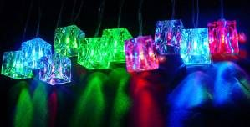 | ITEM NO: L-5866F LED STRING – ICE CUBES  PRICE : FOB GUANGZHOU US$8.70/SET for UL  US$8.80/SET for EU  US$9.00/SET for BS  DESCRIPTION: 2” x 10 pcs for 6M length by LED  Color-changing  Power by Adaptor  PACKING : 1 set/color window box/ 18 x 8.5 x 20cm,  24 set/cnt/ 2.96 cuft/ 52.5 x 37.5 x 42.5cm/  10.0 kgs/ 14.0 kgs
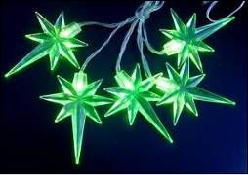 | ITEM NO: L-5866G LED STRING – STARS  PRICE : FOB GUANGZHOU US$8.50/SET for UL  US$8.60/SET for EU  US$8.80/SET for BS  DESCRIPTION : 3” x 10 pcs for 6M length by LED  Color-changing  Power by Adaptor  PACKING: 1 set/color window box/ 22.5 x 6 x 14.7cm,  12 sets/ctn/ 1.05 cuft/ 38 x 24.5 x 32cm  8.0 kgs/ 9.8 kgs
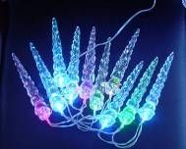 | ITEM NO: L-5866H LED STRING – ICICLES  PRICE : FOB GUANGZHOU US$8.70/SET for UL  US$8.80/SET for EU  US$9.00/SET for BS  DESCRIPTION: 3” x 10 pcs for 6M length by LED  Color-changing  Power by adaptor  Packing: 1 set/color window box/ 22.5 x 6 x 14.7cm,  12 sets/ctn/ 1.05 cuft/ 38 x 24.5 x 32cm  8.0 kgs / 9.8kgs
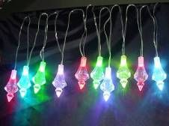 | ITEM NO : L-5866J LED SGRING – ICICLES  PRICE : FOB GUANGZHOU US$8.90/SET for UL  US$9.00/SET for EU  US$9.20/SET for BS  DESCRIPTION: 2” x 10 pcs for 6M length by LED  Color-changing  Power by Adaptor  PACKING: 1 set/color window box/ 20 x 10 x 20cm,  24 sets/ctn/ 3.92 cuft/ 61.5 x 42.6 x 42.4cm  10.8 kgs/ 12.5 kgs
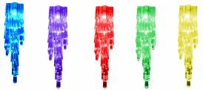 | ITEM No: L-5866K LED STRING – ICICLES  PRICE : FOB GUANGZHOU US$8.90/SET for UL  US$9.00/SET for EU  US$9.20/SET for BS  DESCRIPTION:6” x 10 pcs for 6M length by LED  Color-changing  Power by Adaptor  PACKING: 1 set/color window box/27.5 x 24 x 6.5cm,  12 sets/ctn/ 4.14 cuft/ 56.5 x 50 x 41.5cm  11.0 kgs/ 15.0 kgs
MOQ: 1,000 set/item

