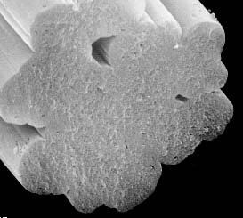
奈米天然水晶具有高度吸濕效果，加上Talent Yarn® (天人紗)橫切面外觀圖為”花朵狀” (花朵形,8-11道溝槽)，故纖維本身即具有永久性高吸濕,快乾之功能。

Talent Yarn® cross section of the yarn appears to be “blossom type”(8-11 stripe).
Because of this function, the fiber has two kind of abilities: high water absorptivity and fast dry.

